ECE 441 Fall 2021

WEEK #5 GROUP MEETING LOG

Lab Session: 2

Group Number: 2

Instructor: Dr. Jafar Saniie

Due Date: 02-16-2022

Acknowledgment: I acknowledge all of the work (including figures and codes) belongs to me and/or persons who are referenced.

Member 1: Alan Palayil

Member 2: Fabian Garcia

Member 3: Gabriel Gutierrez

[Smart Mirror - *Through the Speculum*]

**Project Goal:**

* Create a smart mirror with gesture control and face recognition.
* Include accessories like LED strips and a sound system.

**Standards used in Project:**

Not applicable during this stage of the project

**System Constraints:**

* Budget
* “Plug in play”
* Easy to use

**Prior Knowledge Acquired Critical to Design Project:**

ECE 100, ECE 211, ECE 213, ECE 218, ECE 242, ECE 307, ECE 308, ECE 311, ECE 319, ECE 407, ECE 411, ECE 436, ECE 438, ECE 485, CS 115, CS 116, CS 330, CS 331, CS 350, CS 351, CS 450

Note: CS 331- Data Structures and Algorithms (Python Programming)

Meeting 1

| Date | 2/12/2022 |
| --- | --- |
| Start Time | 1:00 PM |
| Duration | 2 hours |
| Attendance | All attended |

1. **Agenda**

Continue talking about the next steps for our project. Our parts lists have been finalized. Now we are checking what we need in order to continue with our design. As a team we went over the components list and made any additional changes for items that we may have forgotten and prepared it for submission.

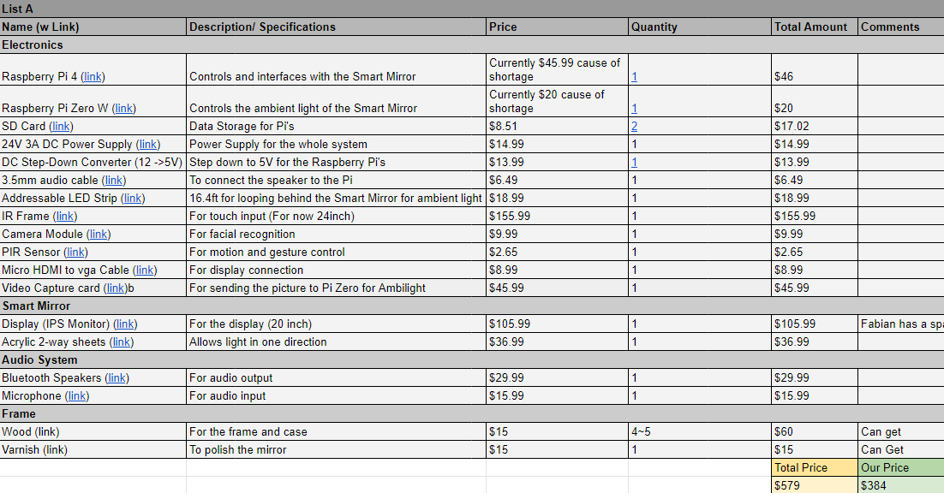

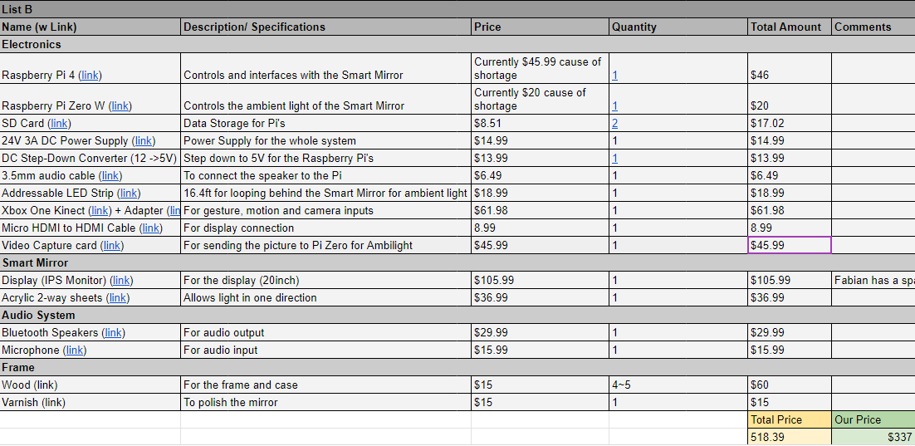

Secondary List in case our initial plan is not feasible in the time and budget allowed.

We then spent the rest of the meeting discussing the proposal

**Fabian**

Current Monitor is a 20” Widescreen Display. It has a resolution of 1600x900 and uses DVI and VGA cables.

1. **Tasks**

| **1 - Idea development** | | |
| --- | --- | --- |
| **Task** | **Assigned to** | **Due Date** |
| Continue Work on Proposal | Team | 2/24 |
| Submit finalized component list | Team | TBD |
| Implement a simple OpenCV gesture control on the raspberry PI | Gabriel | 2/14 |
| Email the TA the component list | Alan | TBD |
| Set up Raspberry Pi 4 | Fabian | TBD |

1. **Work Distribution**

| **Alan Palayil** | Help in setting up the current steps required by each member to be on the same track and work ahead. Also finish debugging the Alexa API error which arised. |
| --- | --- |
| **Fabian Garcia** | Gathered current monitor and its specifications. Will set up Personal Raspberry Pi to begin testing. |
| **Gabriel Gutierrez** | Finished setting up the Raspberry Pi 3 that was supplied by the TA |

1. **Progress and Milestones**

Came together and finalized the current parts list. Began looking forward and began talking about the next steps for our proposal.

1. **Next Steps**

The next step involves emailing the TA the components list, and also beginning work on the Proposal.

Next meeting: Monday the 14th.

Meeting 2

| Date | 2/14/2022 |
| --- | --- |
| Start Time | 1:00 PM |
| Duration | 2 hours |
| Attendance | All attended |

1. **Agenda**

Discuss progress and setbacks

Progress report:

* Theme
* Contents of the report

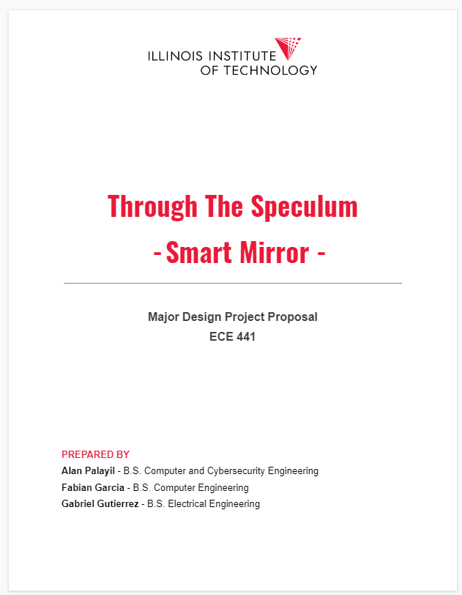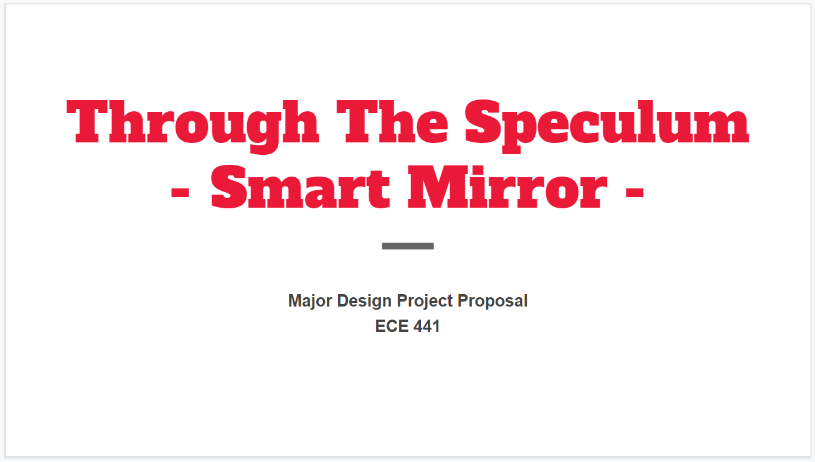

Gabriel:

* Set up the progress report
* Successfully set up OpenCV on the Raspberry Pi 3 provided by the TA; however, after trying to set up a VNC server, the Raspberry Pi gets stuck on an infinite login loop. Will have to reinstall a fresh install of Raspbian. (Alan has provided an alternative solution to set-up the VNC server on the raspberry PI.

This image shows a successful VNC connection using Alan’s Raspberry PI.

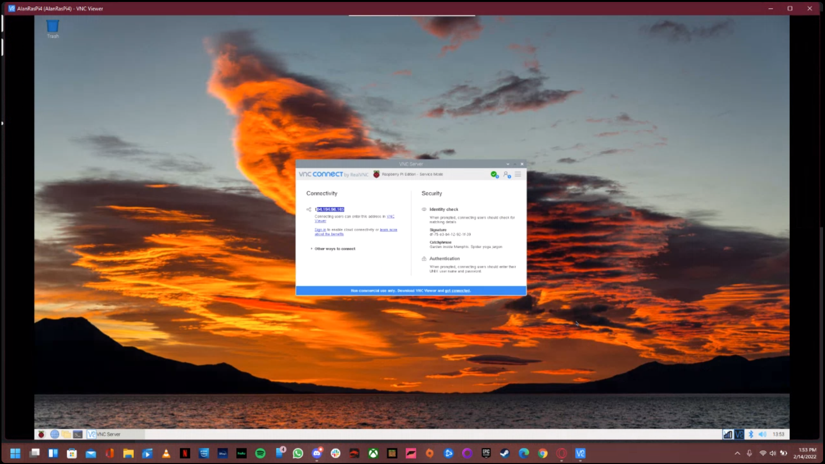

Alan:

Still debugging the Alexa Voice API, as one of the key (Wake Sensory) repositories was deleted and the system can’t be built without it. Checked and confirmed that the Google Assistant API was working and started on boot.

Fabian:

Set up personal Raspberry Pi for remote access. Still figuring out how to allow for Alan and Gabriel to connect remotely. As of right now, I am only able to connect. Once this is sorted, I will begin implementing OpenCV align with Gabriel in order to move forward with the gesture control and facial recognition features.

1. **Tasks**

| **1 - Idea development** | | | |
| --- | --- | --- | --- |
| **Task** | **Assigned to** | **Due Date** | **Comments** |
| Continue Work on Proposal report | Team | 2/24 |  |
| Proposal presentation | Fabian and Gabriel | 2/19 |  |
| Record current progress and attach it to the proposal | Alan | 2/21 | To add videos of the working attachments and work on the proposal. |
| Submit finalized component list | Team | TBD |  |
| Implement a simple OpenCV gesture control on the raspberry PI | Gabriel | 2/19 | Set back until the next meeting due to an infinite log-in bug |
| Email the TA the component list | Alan | TBD | Completed |
| Set up Raspberry Pi 4 | Fabian | TBD | Completed |

1. **Work Distribution**

| **Alan Palayil** | * Complete the set back that took place in the Amazon API. Add video attachments of the current working features. |
| --- | --- |
| **Fabian Garcia** | * Work on OpenCV to add gesture control to different modules which will be used like play next or back, pause and play. * Work on proposal |
| **Gabriel Gutierrez** | * Set up Raspberry Pi 3 * Begin proposal |

1. **Progress and Milestones**

Alan’s raspberry pi is connected to a VNC server, so it can be remotely accessed and worked on by the team.

1. **Next Steps**

As a team we need to complete the proposal before the 25th. We will also be working on our presentation.

Our next meeting is Saturday the 19th.